One-Room Schoolhouse Day at Your School:
Cool clothes, fun food, and rad rules in the comfort of your own classroom.
In this lesson, children will plan a special day at school to experience and share the one-room classroom. Children will compare and contrast clothing, lunch carriers, foods and schoolhouse rules100 years ago with those of today. They will learn about changes in lunch carriers over a chronological period. They can even make their own lunch pails if desired.

8.1.3.A: Understand chronological thinking and distinguish between past, present and future time (time lines; continuity and change).
8.1.3.C: Understand fundamentals of historical interpretation (difference between fact and opinion; multiple points of view).
5.1.4.A: Examine school rules and consequences.
5.1.4.B: Explain rules and laws for the classroom, school, community, and state.
5.2.4.A: Identify individual rights and needs and the rights and needs of others in the classroom, school, and community.
5.2.4.B: Describe the sources of conflict and disagreement and different ways conflict can be resolved.
8.3.4.B: Locate historical documents, artifacts, and places critical to United States history.
________________________________________________________________________
Objectives for Activity III:
Students will be able to:
Describe the different articles of clothing that school students wore. Identify past and present lunch choices and describe a student’s lunchbox from the late 1800s and early 1900s. Be able to show a chronology of lunch pails to peers. List rules and discipline in a one-room classroom.
________________________________________________________________________
Setting the Stage: Guided Discussion
Help the students to think about all students over 100 years ago. Generate some guesses and predictions about children and school in the United States over 100 years ago.
Ask the students:
1. Do you think school students, 100 years ago, dressed like you do now? Why or why not? When you see different clothing, how do you know if the clothes are from a long time ago or are designed for the future? Describe the differences? Can you guess how old they are or what period in the future they are for? [Guide the students to consider what types of fabrics could be made a long time ago, like cotton and wool and linen. Lead them to think about where the raw materials were sourced, like wool from local sheep, cotton and linen from local plants or plants from the southern states (linen from flax plants)? Guide them to think about contemporary fabrics and fabrics of the future. Contemporary fabrics use man-made raw materials like polyester and lycra; some are very high-tech, like a local fabric product called Gore-Tex®. Lead the students to consider how clothing was made and who made it over 100 years ago and today.]
2. Do you think school students, 100 years ago, ate the same foods that you eat now? Why or why not? Guess whether you or the families over 100 years ago have/had more food choices? Explain why you chose your answer? [Lead children to think about how people got their food over 100 years ago, growing it, trading it, or buying it from markets and traveling merchants. Lead children to understand that there were more varieties of fruits and vegetables because they didn’t need to ship them so far. Today’s food is selected to travel and store well. Ask them if they see black, red, or white carrots at the grocery store? Tell them that they can still grow such carrots, if they’d like. Lead children to talk about foods today versus foods a long time ago.] Ask them to describe an Oreo® to a school student in 1870. How could they explain the taste, texture, and appearance using words and comparisons that would be familiar to them.
Ask students how they think schoolchildren carried their lunches to school. [If they visited the Locust Grove Schoolhouse, they should have an idea about the carriers.]
3. Who do you think has/had more rules to follow, students today or students in one-room schoolhouses, over 100 years ago? Who do you think had harder consequences, students today or students over 100 years ago? Who do you think has/had more fun, students today or students over 100 years ago? [Remind the children that the rules and discipline were created to maintain order and safety for a community of children aged 5 through 18 in one classroom. Ask them to consider how their own classroom runs; ask them to imagine their classroom, but every day there were new and different students, and some days the class would have 10 students and other days 35 or more.]
4. What date would you like to schedule for our One-Room Schoolhouse Day? [Help the children to select a day and put it on the calendar. Schedule time to plan and organize events, and coordinate help from parents and teachers if any purchases are necessary. Motivate the children to publicize their event in their school.]
If possible, record students’ guesses and predictions for all to see.
________________________________________________________________________
Lesson:
Students plan and execute a One-Room Schoolhouse Day in their own school. Students will decide how to bring the one-room schoolhouse to their own school using dress, food, and rules from over 100 years ago. Students can brainstorm ideas for sharing their day with other ages and groups in their school. For example, possibly invite another classroom to share lunch or to visit their room to learn about dress, food, and rules.

Divide students into three planning committees: one for dress, one for food/lunch, and the last group for determining rules for the day. Resources are provided to help the students begin their planning. Don’t forget to ask the students to plan for any clean up and permissions they’ll need.

One-Room Schoolhouse Day—Cool Clothes

Group One:
History Fashionistas (a.k.a. the Dress Committee)
Responsibilities:
Create a special dress code for the day and educate your peers about late 19th and early 20th-century dress.
First look at the following photos and the photos provided for Activity One, Group One Resources (images 1, 2, and 3; pages 5, 6, and 7). These show a range of historic dress for school children. Read the following list of historical dress for children. After studying these resources, make your own dress code for the One-Room Schoolhouse Day. You may want to restrict clothing items, like, “No Sneakers, only hard shoes, boots, and dress shoes.”

Good Luck, History Fashionistas!

Resources:
Photos of School Students, Northeast PA, US
Copyright by Nepa Photos (NEPA = Northeast PA)
http://freepages.genealogy.rootsweb.ancestry.com/~nepaphotos/people.htm
Learning Centers at Ancestry.com; an Ancestry.com Community

Students from the 1900s:
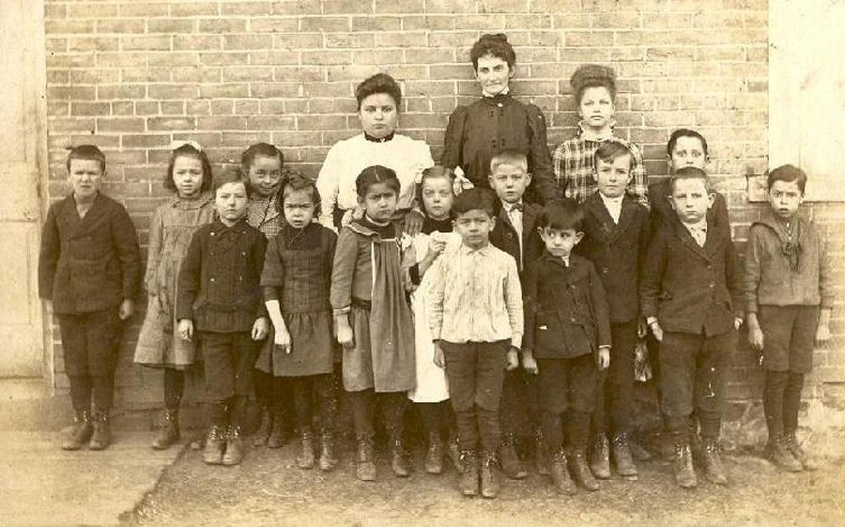

Students from 1909:
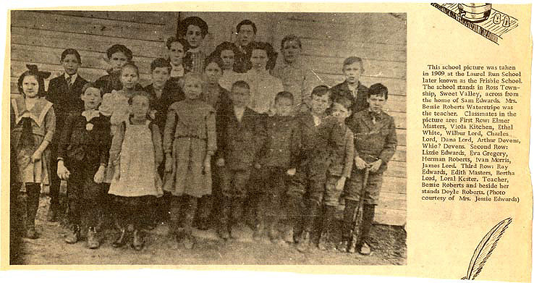
Students from 1915:
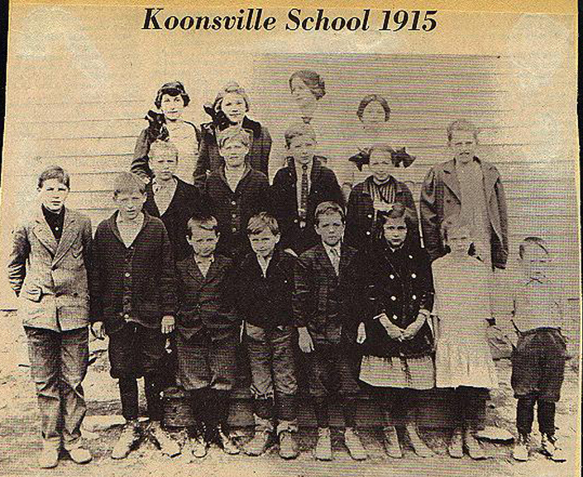

19th-Century Clothing for Boys:
Dark pants; overalls; white, plaid or striped shirt; suspenders; bandanas (as neck scarf or handkerchief); dark shoes and socks; flat caps or straw hats. Short pants and dark knee socks.
19th-Century Clothing for Girls:
Mid-calf or ankle length skirts or dresses in solid colors or calico prints; aprons; white blouses; knee socks and dark shoes; shawl; bonnet; handkerchief; hair in braids.

One-Room Schoolhouse Day—Fun Food

Group Two
History Hash-Slingers (a.k.a Lunch Committee)
Responsibilities:
First you’ll need to determine whether you’ll provide lunches or ask students to bring in their own. Then create a special lunch code or menu for providing lunch. Decide what kind of lunch carriers to use for the day. Educate your peers about late 19th and early 20th century lunches and carriers.
First check out the following photos to learn about lunch pails from over 100 years ago. Read the activity for making your own historical lunch pail. Share the information with the entire class and/or other classes.
Next read the following list of foods that children might have eaten at a one-room schoolhouse and the information on the foods likely to be in the homes of one-room schoolhouse students. After studying these resources, make your own suggestions for lunch for your One-Room Schoolhouse Day. You may want to restrict food items, like, “No packaged foods, only home-made foods.”

Good Luck, History Hash-Slingers!

Resources:

What kinds of lunch carriers did students have?
Students brought lunches in lunch pails in the nineteenth century. These were made for the purpose of carrying food. Once factory baked biscuits and cookies became popular, families saved the “tins” to use as colorful lunch pails. They also repurposed other packages for coffee and cigars as lunch pails.
If you cannot make lunch pails, consider using brown paper or brown paper bags and waxed paper for all foods. There were no plastic bags in the late 19th and early 20th-centuries. “Food was wrapped in cloth or butcher paper. Students had a tin cup or used the dipper in the classroom to get a drink of water.”

Photos of Lunch Pails
Smithsonian Museum of American History, Behring Center
Taking America to Lunch at http://americanhistory.si.edu/lunchboxes/index.htm

Late 19th-Century Miner’s Tin: Late 19th-Century Miner’s Lunch Pails:
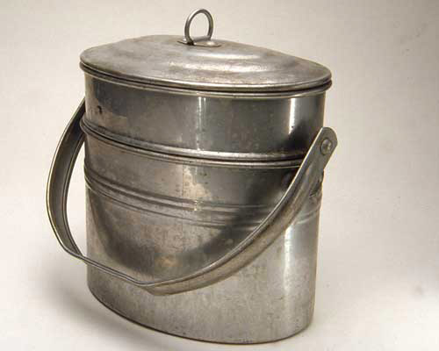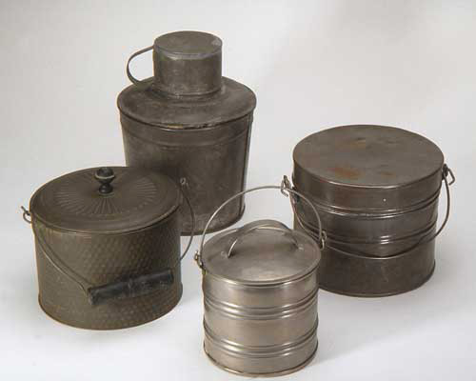

Coffee Tin, Lunch Pail from 1880s: Cigar Tin, Lunch Pail from 1890s:
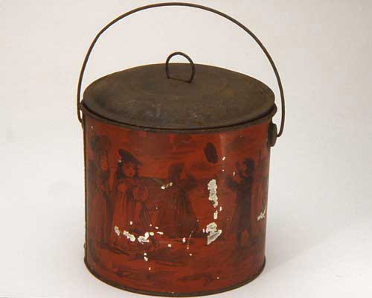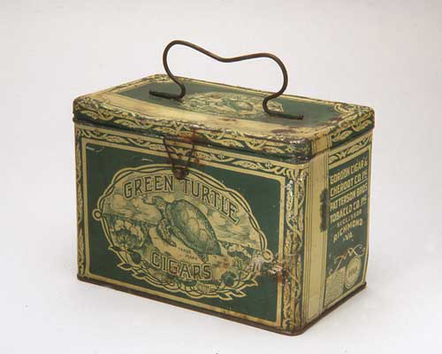

Tobacco Tin, Lunch Pail from 1890s: Tobacco Tin, Lunch Pail from 1890s:
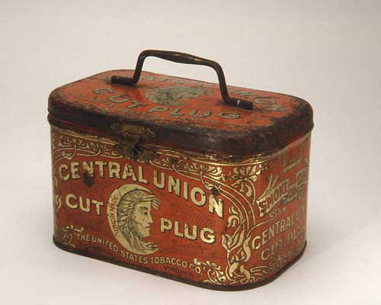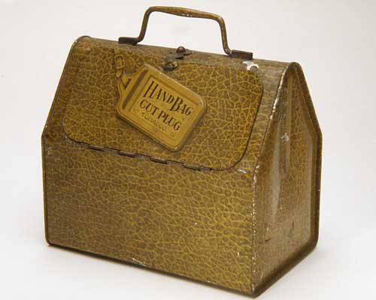

Make your own Lunch Pail Idea
(Inspired by Harn Homestead One-Room Schoolhouse)
Materials needed: shortening cans or coffee cans; heavy string; construction paper; glue; scrap of fabirc for a cover; hammer, nail, & scrap wood for pounding.
1. Glue construction paper to cover can. Keep plain or illustrate as old-fashioned coffee or cookie tins, like the Smithsonian photos show.
2. With teacher’s help: using a nail and hammer, punch two holes on opposite sides of the top of the container. Place nail inside can; pound nail through can onto scrap wood. Turn can over and repeat to create a 2nd hole opposite the 1st.
3. Cut the string and tie a knot at one end. Carefully pull the string through the two holes to form a handle for the bucket and knot the other end.
4. Use a scrap of fabric to cover the food in the lunch bucket.

19th Century Food Possibilities:
Foods that children brought to school needed no refrigeration and were not messy. A typical food might have been a baked sweet potato; cold pancakes from breakfast; or a piece of bread spread with lard and sugar; or a piece of cake.
History hash slingers, read the following excerpt, explaining food resources, before working on your list of approved or suggested foods for your class.
“Most families had a cow. From the cow came butter, milk and cheese. Many farms had pigs to slaughter for meat. Every farm had chickens and there were usually plenty of eggs. Women baked breads. They could make a sandwich on a slice of loaf bread, a biscuit, a cold roll, or on a cold pancake.
There were lots of fruits and vegetables from the garden. Some, such as peaches and green beans, were canned. The orchards generally had apple, cherry, peach, pear and plum trees. Apples and plums could be dried and eaten as a sweet food. Carrots and cabbage stayed fresh in a cold room. Garden vegetables were both canned and pickled.”

One-Room Schoolhouse Day—Rad Rules

Group Three:
History Police (a.k.a. the Rules Committee)
Responsibilities:
Create a special behavior and responsibility code for the day and educate your peers about late 19th and early 20th-century one-room schoolhouse rules and consequences. Educate your peers about the rules and discipline of one-room classrooms.

Read the lists of rules and discipline. Remember that your rules and discipline must be appropriate for all students aged 5 through 18. Also remember that the rules should help to create a safe and orderly environment. Think about whether you’ll enforce the rules all day, or only for an hour or so. It may be hard to sit up straight with both feet flat on the floor—all day!

Good Luck, History Police!

Resources:

One-Room Schoolhouse Rules:
1. All students will be polite and considerate and will demonstrate good manners at all times.
2. Students will sit at their desks, unless given permission to leave their seats.
3. Students will sit straight with both feet flat on the floor.
4. Hands will be folded on the desk when not engaged in schoolwork.
5. Students will raise their hands for permission to speak. When permission is granted, students will stand before speaking.
6. Students will not talk or pass notes among themselves.
7. Students will follow instructions and work without interruptions.
8. Students will not turn around in their seats, or in any manner let their attention wander from their studies.
9. Students will not chew tobacco or spit tobacco in schoolhouse or on grounds.
10. Students will not smoke tobacco in schoolhouse or on grounds.

One-Room Schoolhouse Discipline:
1. Sit in corner and wear the dunce cap when pupils do not recite well.
2. Lose recess when tardy.
3. Clean the floor if the pupil littered or spit.
4. Write a sentence “I will not…” 100 times after misbehaving.
5. Stand with one’s nose inside a circle drawn (rather high up) on the blackboard (for any misbehvior).
6. A boy will be made to sit by a girl if he misbehaves.
7. Students will stay in seats for lunch hour, if lessons are not learned.
This punishment was given at the Locust Grove Schoolhouse. Check out the primary source that records this punishment: it’s image 2 on page 16.
8. Receive a “rap” on the hands or backside for disrespect or severe misbehavior.
This is known as corporal punishment. One of the primary sources, for activity two, shows which students received corporal punishment in 1861 at the Locust Grove School. Check it out: image 1, page 27. SORRY History Police, you can’t add this one to your list, as it is now illegal in the state of Pennsylvania! Whew!

Harn Homestead & 1889ers Museum: Wearing Historical Clothing and Historical Lunch Activity, p. 13-14. Rules and Behavior, p. 18. http://www.harnhomestead.com/LinkClick.aspx?fileticket=pCJKKhB1t5c%3D&tabid=68
Harn Homestead & 1889ers Museum: Wearing Historical Clothing and Historical Lunch Activity, p. 13-14. Rules and Behavior, p. 18. http://www.harnhomestead.com/LinkClick.aspx?fileticket=pCJKKhB1t5c%3D&tabid=68
Smithsonian Museum of American History, Behring Center: Taking America to Lunch at http://americanhistory.si.edu/lunchboxes/index.htm (accessed August 2011).
Harn Homestead & 1889ers Museum: Historical Lunch Activity, p. 13-14. http://www.harnhomestead.com/LinkClick.aspx?fileticket=pCJKKhB1t5c%3D&tabid=68
Harn Homestead & 1889ers Museum, p. 15.
Harn Homestead & 1889ers Museum, p. 14.
Harn Homestead & 1889ers Museum, p. 14.
Harn Homestead & 1889ers Museum: Rules and Behavior, p. 18. http://www.harnhomestead.com/LinkClick.aspx?fileticket=pCJKKhB1t5c%3D&tabid=68
Harn Homestead & 1889ers Museum: Rules and Behavior, p. 18. http://www.harnhomestead.com/LinkClick.aspx?fileticket=pCJKKhB1t5c%3D&tabid=68

